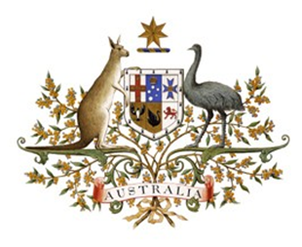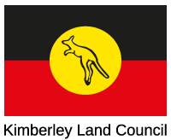

International Savanna Fire Management Initiative
Review of Progress for the Pilot Botswana Site

Date: 3 September 2020

Time:8:30-10:30am Central Africa Time/4:30pm-6:30pm Australian Eastern Standard Time

Venue: Zoom

You are invited to a meeting of the International Savanna Fire Management Initiaitve on Wednesday 3 September 2020.

The meeting will review progress towards adapting Australia’s groundbreaking Savanna Burning Technology in Botswana.

Background information on the Project can be found on the website at www.isfmi.org.

Zoom link: https://zoom.us/j/92923290658

Introductions
- Ari Gorring

Welcome
- Ambassador Jamie Isbister, Australian Ambassador for the Environment
- Director Baitshepi Babusi-Hill, Department of Forestry and Range Resources
- Nolan Hunter, Chair of the Advisory Committee of ISFMI

International Savanna Fire Management Initiaitve Project
- Catherine Monagle
Recent developments in Traditional Fire Management in Australia
- Rowan Foley
Reflections on the Pilot Project
- Jomo Mafoko
2020 Fire Season in Northern Australia, methodologies and remote sensing
- Jeremy Russell-Smith
Carbon markets and climate change policy
- Lauren Drake, Martijn Wilder
Discussion on next steps – Moderated by Sam Johnston

