Meeting Notes
International Savanna Fire Management Initiative (ISFMI) Review of Progress for the Pilot Botswana Site

3 September 2020, via Zoom

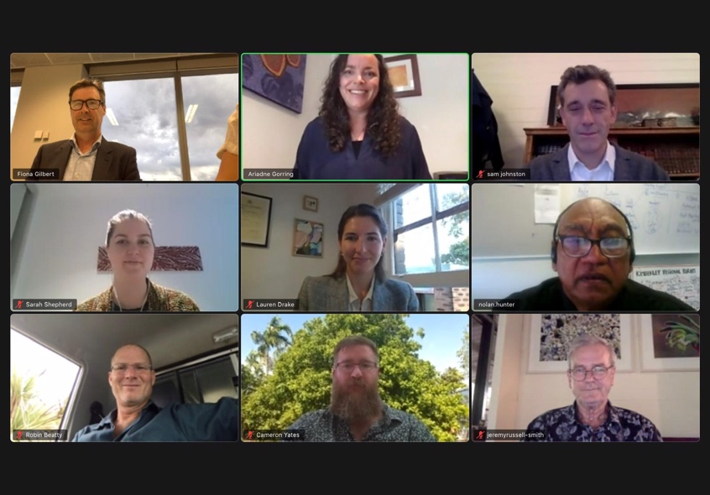
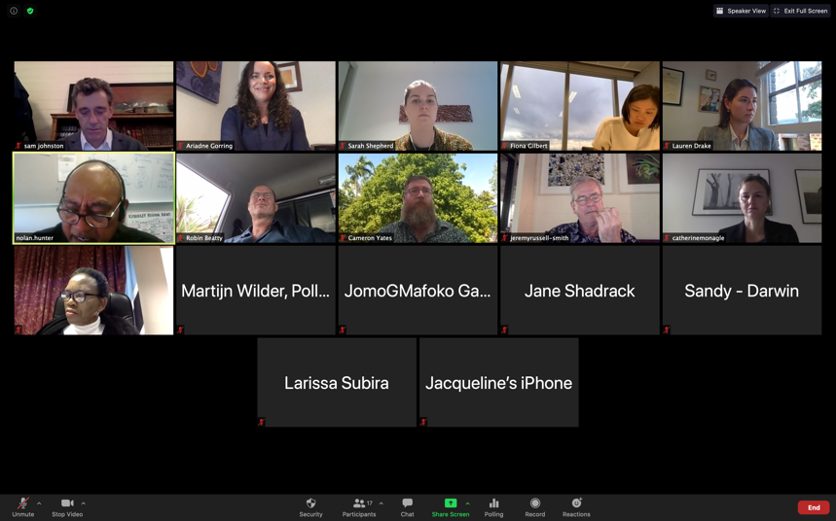
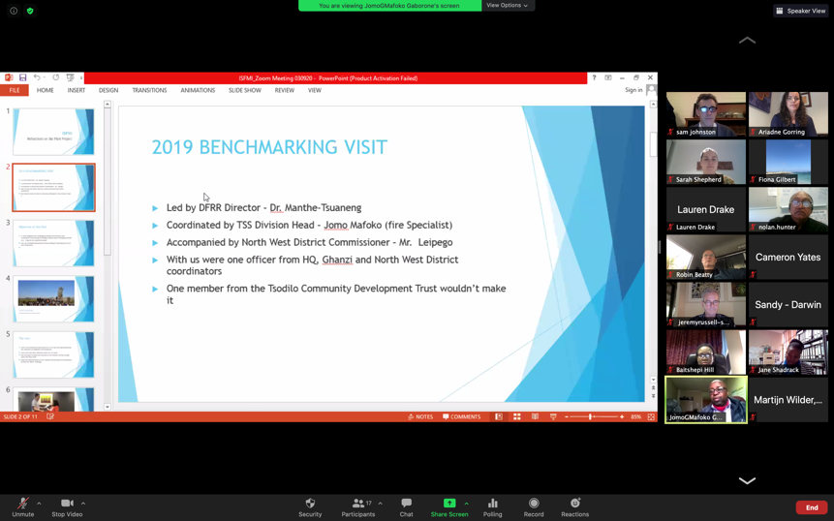
Participants:
Government of Botswana
- Ms Baitshepi Babusi-Hill, Director, Department Forestry and Range Resources, Botswana
- Mr. Jomo Mafoko – Department of Forestry and Range Resources, Botswana
- Ms Jane Shadrack – Department of Forestry and Range Resources, Botswana. Principal Technical Officer Fire Management
Australian Government
- Mr Jamie Isbister – Australian Ambassador for The Environment
- Ms Fiona Gilbert – Australian Department Foreign Affairs and Trade
- Mr Richard Neumann – Australian Department Foreign Affairs and Trade
- Ms Jacqueline DeRose – Australian Department Foreign Affairs and Trade, Africa Branch
- Ms Sandra Henderson – Australian Department Foreign Affairs and Trade, Darwin Office
- Ms Larissa Subira – Australian High Commission, Pretoria
- Ms Somatata Kone – Australian High Commission, Pretoria
International Savanna Fire Management Initiative and Partners
- Mr Nolan Hunter – Chair, ISFMI Advisory Committee. CEO Kimberley Land Council
- Mr Sam Johnston – ISFMI Programme Director
- Ms Catherine Monagle – ISFMI Programme Manager
- Professor Jeremy Russell-Smith – Darwin Centre Bushfires Research
- Dr Cameron Yates – Darwin Centre for Bushfires Research
- Mr. Robin Beatty – Managing Director, 321 Fire
Pollination Foundation/Pollination Group
- Ms Ariadne Gorring – Executive Director, Pollination Foundation
- Ms Sarah Shepherd – Pollination Group
- Mr. Martijn Wilder AM – Co-founder, Pollination Group
- Ms Lauren Drake – Pollination Group
Apologies
- Mr Gregory Andrews – Australian High Commissioner to Ghana
- Ms Cissy Gore-Birch – ISFMI Advisory Committee, Executive Manager Aboriginal Engagement, Bush Heritage Australia
- Mr Rowan Foley – ISFMI Advisory Committee, Aboriginal Carbon Foundation (note: presentation provided)
Introduction to the Meeting:
Ms Ariadne Gorring, Executive Director of Pollination Foundation welcomed all attendees and reminded all that the purpose of meeting was an informal session to catch up and reconnect on progress in and next steps for the International Savanna Fire Management Initiative project in Botswana. Participants briefly introduced themselves.
Welcome:
Mr. Jamie Isbister, Australian Ambassador for The Environment, provided a Welcome to Country.
Mr Isbister noted he had spent 4 years in South Africa, and this program had been in place during that time. He added that it was great to see how it has continued to grow not just in Australia, but now with other countries. The program highlights how communities can take action and these types of initiatives are important to bring life to delivering outcomes for communities. Nature based solutions has a strong focus moving into COP26 in Glasgow, and he is looking forward to working with attendees to bring together all initiatives for nature-based solutions.
Mr Nolan Hunter, Chair of the ISFMI Advisory Committee, provided a Welcome to Country and acknowledgement of all traditional owners of the land. He acknowledged the important role of indigenous people in response to the challenges posed by climate change. Despite the challenges in remote areas with COVID, Mr Hunter noted there are lessons to be learned in Australia regarding traditional landowner knowledge, with opportunities in respect of carbon abatement. Mr Hunter closed by recognising that, as Indigenous peoples, additional opportunities are provided through these projects, in addition to the climate change benefit through maintaining a direct traditional connection to the land.
Ms Baitshepi Babusi-Hill, Director, Department Forestry and Range Resources, Botswana welcomed all, and noted that she had familiarised herself with the programme including through the documentation provided. Recently the Director had the opportunity to discuss firefighting techniques, and discussed Botswana’s experience working with Australia, noting there was much interest in this among communities and practitioners. Director Baitshepi hoped that the planning could move forward, so that when COVID allows, the project can recommence in the field. Director Baitshepi relayed that the Secretary appreciated the local and Indigenous knowledge that had been shared across the two countries to date.
Following the welcomes, the following presentations were made.
Presentation 1:
Mr Jomo Mafoko presented on reflections on the 2019 benchmarking/pilot project.
The 2019 trip to Australia was led by the Director, Department of Forest and Range Resources Botswana, and the objective of the visit was a benchmarking trip to capture indigenous knowledge on fire management. The group met with fire rangers from the Kimberley with the intention to harness the knowledge of old ways of supressing fires. The group learned from the local people, learned more about the ownership of fire management in Australia and noted the importance of the local and indigenous people running and being responsible for fire management with officials supporting these activities. The visit led to identification of many similarities between Australia and Botswana. During this trip, the MoU between the LDI and Department of Forestry was signed, marking the beginning of the formal cooperation between the two countries for implementation of the project.
The Australian Group then attended the fire conference in Maun, and the site selection was made when the team from Australia visited Botswana, starting with Tsodilo Hills and the Chobe Region.
Challenges raised included malfunction of fire detection stations. Lack of resources for local communities, including a lack of the protective clothing required. The 2020 rainfall outlook is good, with good rain expected, however there is an indirect relationship with rainfall and fire for the next year. It was noted the project will investigate the challenges to identify where ISFMI can assist.
In conclusion: Mr Mafoko’s presentation identified Traditional Fire Management as important in emissions reductions and carbon trading, and a seeing the benefit through carbon trading helps underline the value of the project.
Presentation 2:
Professor Jeremy Russell-Smith presented an overview of the history of the work done in Northern Australia and of the actions taken to date in Botswana.
The initial feasibility studies show that this methodology is very feasible in Botswana. Annual fire regimes of the north are similar to Botswana with not much burning in the early dry season. Prof. Russell-Smith spoke about the history in the northern Australia region in which ConocoPhillips set up a liquified plant in Darwin Harbour and were required to offset. The company spoke to traditional owners and signed a 17-year contract with the Western Arnhem Land Traditional Owners. A great deal of capacity was built through this process, in which TOs use aerial and land techniques, including leaf blowers, to ignite and then manage methodology based early dry season low intensity burning.
Jeremy’s presentation provided data on fires and the emissions produced in Botswana in the late dry season associated with the late dry season fires. Providing detail of the pilot program with an example of the Tsodilo enclave, where prescribed burning was undertaken with fire teams, the burning was very effective to protect the assets of the Tsodilo hills. A great deal of progress has been made in collecting the necessary data to demonstrate feasibility of a methodology based approach in Botswana. A draft is being prepared for publication in an international scientific journal to show opportunities to demonstrate the applicability in Botswana and remaining challenges, including the need for further local capacity building and training.
Presentation 3:
Ms Lauren Drake and Mr. Martijn Wilder AM presented on legal and governance frameworks and carbon markets.
The host of the ISFMI project is the Pollination Foundation, and the Pollination Group provide climate change law and governance advice. The mandate of the Pollination Group in this project is to provide a detailed law and governance review. Pollination have been working with legal experts in Gaborone to this end, to explore existing frameworks and remaining issues and needs. The legal review includes looking at general regulation, permitted activity, regulatory approvals, landholder approval and liability issues.
Mr. Martijn Wilder made a number of observations on the issue of emissions reductions targets and carbon markets, noting that Botswana has a commitment to a 15% reduction in emissions. With the Glasgow Conference of the Parties of the UNFCCC being pushed back, the market for carbon abatement is in a state of flux, with voluntary carbon credits important in this context.
Legal and governance considerations emissions reductions activities through managed burning include land tenure, restrictions, permits required, government claim and benefits sharing.
Director Babushi-Hill enquired as to whether the Pollination Group had been in touch with Botswanan stakeholders regarding carbon markets, and whether that was something to be considered as part of the project. Ms Drake and Mr Wilder noted the work that had already been done in reaching and discussing these issues with Botswanan stakeholders and the next steps for continuation of that progress towards finalising initial findings and broadening discussions on accessing carbon markets. Mr Wilder noted more broadly that the Pollination Group are currently working with Gabon and Indonesia on domestic carbon markets, and as part of the stakeholder consultations Pollination would like to consult with different Ministries and Departments in Botswana to get feedback on the legal and governance assessment.
Presentation 4:
Ms Catherine Monagle of the ISFMI gave an overview of the ISFMI process and project to date, noting the history and origins of the project, the key elements of the Australian experience, and progress made in both the current and previous phases of the project, both funded by the Australian Government through the Australian Department of Foreign Affairs and Trade/Australian Aid. Ms Monagle noted the findings of the Initiative’s Global Feasibility Studies, and progress made in exploring the practical potential of the approach in other countries in Southern Africa and in other regions of the world.
Next Steps:
Mr Sam Johnston, Programme Director of the ISFMI opened the discussion for questions. The ISFMI team informed the participants that notes from the meeting and a copy of the presentations would be provided to participants following the meeting.
As a summary of next steps, it was agreed that practically, the fastest approach to the issue of carbon markets access would be to generate interest from the private sector, as had initially occurred in northern Australia. As with the example in northern Australia, the original agreement was a voluntary agreement without a legislative framework around it. In Australia, such private arrangements informed later government frameworks. Also important would be accreditation under with voluntary carbon market standards, but the main delay to that end is then having a methodology, noting that it is critical to be able to prove what was being sold was credible. Discussions took place on existing accredited carbon sequestration methodologies, noting the advantages of emissions reductions methodologies for community led activities. On the issue of how close we are to producing a methodology , the significant progress made already was outlined, A methodology notwithstanding, participants noted the importance of the long term commitment required in terms of Monitoring, Reporting and Verification and local capacity building to build long term home grown capacity for this work. A key early step in this capacity building is to engage students and have them enrolled in tertiary studies, leading to them ultimately contributing to the building of institutional capabilities within Botswana. Participants from the ISFMI and the Government of Botswana noted the need to return to Botswana as soon as possible to continue project activities and make further progress in person.
In closing Director Babushi-Hill offered to provide support to the technical team and will keep in contact with the ISFMI for any support whilst waiting for both parties to meet physically. Mr Mafoko noted the need to set up a new committee to move forward.
Ms Fiona Gilbert, on behalf of Mr Jamie Isbister, Australian Ambassador for The Environment, noted the importance of the project and the progress that had been made and looked forward to its continued progress.

